Revision History
Date | Version | Description | Author
22/11/2018 | 0.1 | Edited Software Architecture Overview and Software Design Description | Arman Hasanzade,  Güneş Büyükgönenç
23/11/2018 | 0.2 | Edited the Software Design Description 3.2 | Arman Hasanzade
23/11/2018 | 0.3 | Edited the Software Design Description 3.3 | Arman Hasanzade
23/11/2018 | 0.4 | Edited Project References 1.1.1 | Kaan Kırlı
23/11/2018 | 1.0 | Edited the Table of Contents and Introduction and finalized the paper | Arman Hasanzade,

TABLE OF CONTENTS
Revision History 1
1 Introduction 3
1.1 References 3
1.1.1 Project References 3
2 Software Architecture overview 3
3 Software design description 3
3.1 GUI 3
3.1.1 Component interfaces 3
3.1.2 Component design description 4
3.1.3 Workflows and algorithms 4
3.1.4 Software requirements mapping 4
3.2 Operations 4
3.2.1 Component interfaces 4
3.2.2 Component design description 5
3.2.3 Workflows and algorithms 5
3.2.4 Software requirements mapping 5
3.3 Database 6
3.3.1 Component interfaces 6
3.3.2 Component design description 6
3.3.3 Workflows and algorithms 6
3.3.4 Software requirements mapping 6
4 COTS Identification 6

Introduction

This document describes the design of the SUP software system.

References

Project References

# | Document Identifier | Document Title
[SRS] | SUP-SRS-1 | SUP Software Requirements Specifications
[R1] | MSPain3D | https://www.microsoft.com/tr-tr/p/paint-3d/9nblggh5fv99#activetab=pivot:overviewtab
[R2] | Gimp | https://www.gimp.org/

Software Architecture overview

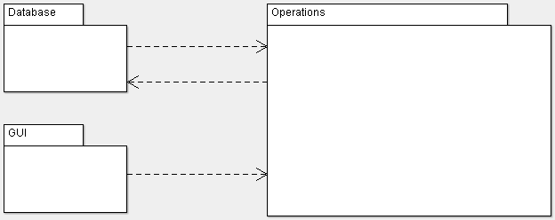

Software design description

GUI

Component interfaces

- initialize() : void -> Used for initializing frame with specified values like size, resizability, and etc.
- paint(Graphics) : void -> Takes Graphics object as input and changes the drawing panel accordingly.
- setOptionPanel() : void -> Sets the panel on top of the drawing panel where the user will be able to pick brush colors, sizes and etc.
- setDrawingPanel() : void -> Sets the center panel which will be used for displaying drawings
- This component extends JFrame/JPanel/JButton/JLabel/JTextField classes

Component design description

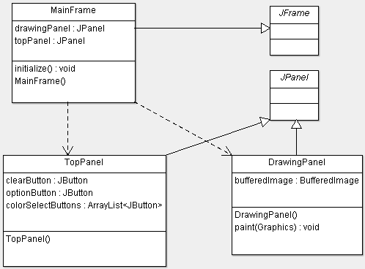

Workflows and algorithms

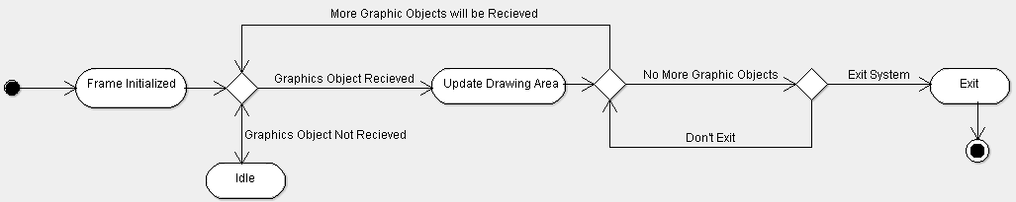

Software requirements mapping
- SRS-SUP-001
- SRS-SUP-009
- SRS-SUP-010

Operations

Component interfaces
- setSaveDirectory(String) : void -> Sets the directory in which the user’s files will be accessed.
- saveAsJPG(BufferedImage) : void -> Saves the drawing in drawing area to the user’s computer.
- openJPGImage() : BufferedImage -> Opens an existing JPG file from user’s computer and displays it on the drawing area.
- getBrush() : Brush -> Returns the selected brush from the Brush list.
- createBrush(String, int, Color) -> Creates a custom brush with parameters name, size, and color.
- setCurrentBrush(Brush) : void -> Sets the current brush with its attributes which will affect the drawing area.

Component design description

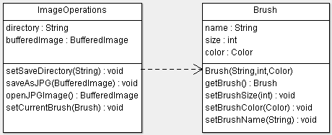

Workflows and algorithms

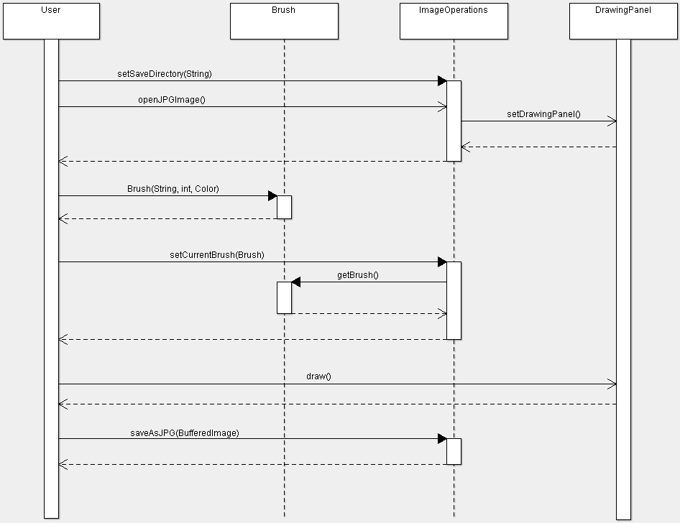

Software requirements mapping
- SRS-SUP-002
- SRS-SUP-003
- SRS-SUP-005

Database

Component interfaces
- connect() : void -> creates a SQL Database connection to our Database URL
- closeConnection() : void -> safely closes the Database connection
- saveBrushToDatabase(Brush) : void -> saves the brush to Database
- getBrushFromDatabase(String) : Brush -> Returns the brush with the given name if it exists in the Database

Component design description
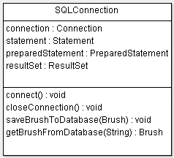

Workflows and algorithms
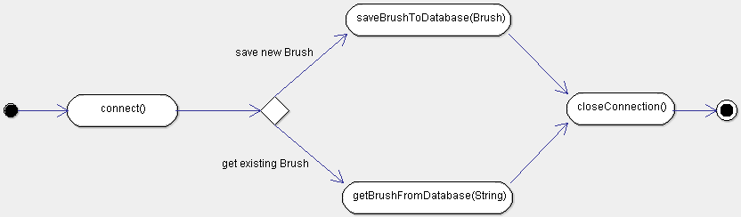

Software requirements mapping
- SRS-SUP-004
- SRS-SUP-006
- SRS-SUP-011

COTS Identification
Libraries Used
- Javax.swig and Java.awt for GUI related Objects (Frame, Panel, Button, etc.)
- Java.util for Lists and ArrayLists.
- Java.SQL for SQL Database connection.

